TP2 Création de Controller symfony 4

Creation of the first page

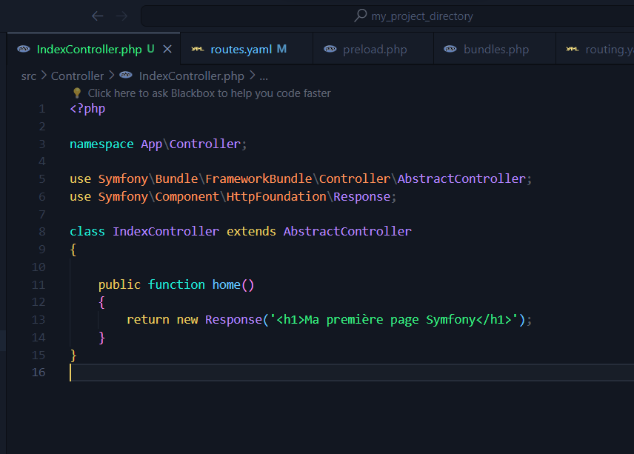

Changing the path

Change the routing

Change the controller path

First html.twig file

Change the routing

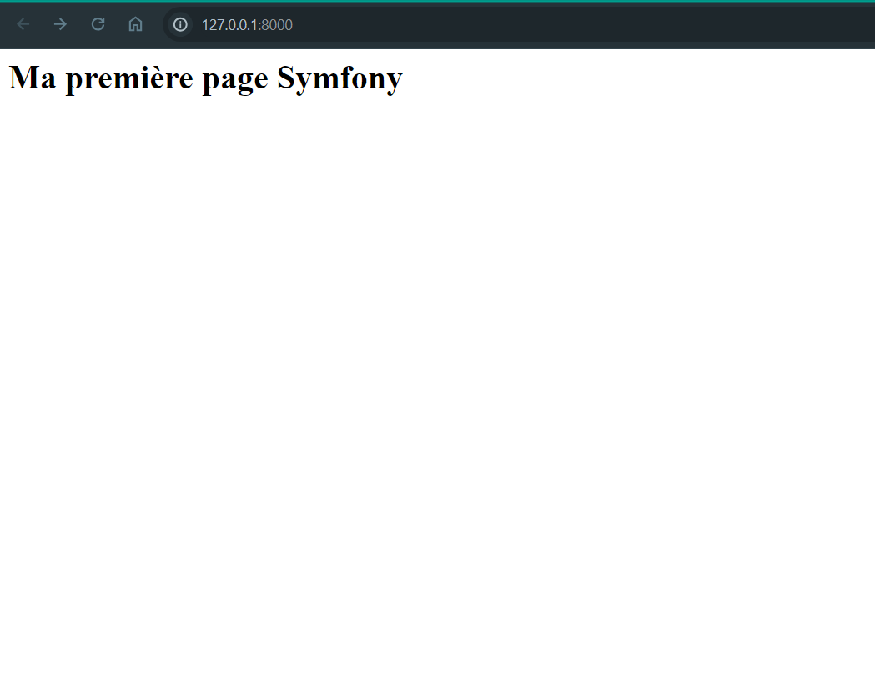

Display a value

